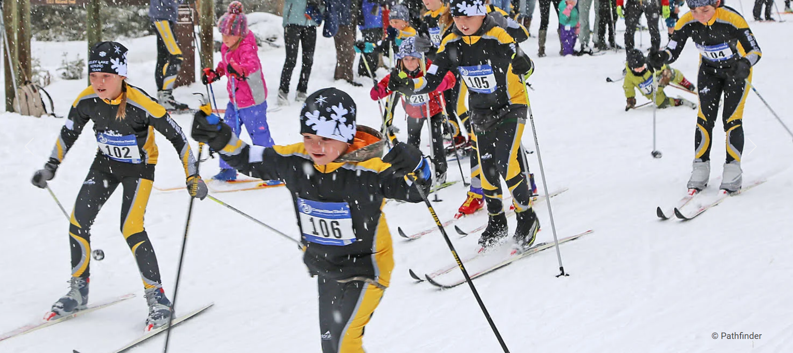  - 11th Annual SKIESTA  Saturday, January 21, 2023  Freestyle Nordic Ski Race for Youth and Adults  - 20K starts at 1:00 $35 per skier  - 1K starts at 1:05 FREE  - 10K starts at 1:10 $25 per skier  - 5K starts at 1:15 $25 per skier  - 3K starts at 1:20 $25 per skier  All races count toward MT Cup standings  Awards for top 3 in age group, distance, male/female | Register online at runsignup.com  ____  Pick up bibs in the Yurt beginning at 10:00 on race day  ____  Food, Awards, Prizes after the race at the Yurt!  ____  All proceeds benefit the Seeley Lake Elementary Outdoor Program  ____  Seeley creek ski trails  16664 Morrell Creek Dr.  Seeley Lake, Montana  406-210-0012  Seeleylakenordic.org  January 21, 2023

